 | Dinkarrao K. Shinde Smarak Trust’s,  DR. A. D. SHINDE  INSTITUTE OF TECHNOLOGY  Approved by AICTE, Delhi, DTE Mumbai and Govt. of Maharashtra, Affiliated to MSBTE, Mumbai.
=============================================================================
DEPARTMENT OF COMPUTER ENGINEERING

NEWSLETTER

ACADEMIC YEAR- 2025-26 TERM- II
===========================================================================

- FROM THE DESK OF PRINCIPAL

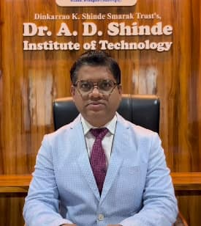 | Dr. A. D. Shinde Institute of Technology is one among reputed technical institutions imparting finest quality education. The evolution of the Institute over the past years has committed to provide professional education with thrust on creativity and innovation.  In DADSIOT, it is believed and practiced that excellence is a continuous process and in pursuit of which the institute has made deep forays into contributing world renowned technocrats, successful entrepreneurs, competent leaders, innovative scientists and researchers.  I assure the academic, professional and social growth of upcoming engineers at our Institute and wish very all the best to my students for an excellent learning experience at DADSIOT.
Dr. Sanjaykumar M. Ingale,
Principal,
Dinkarrao K. Shinde Smarak Trust’s,
Dr. A. D. Shinde Institute Of Technology

- FROM THE DESK OF HOD

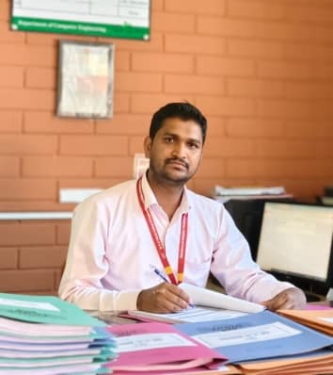 | The Department of Computer Engineering (CO) is dedicated for ensuring great careers for its students. For us, this means forging deeper industry linkages than ever before, creating a research culture from day one and ensuring seamless education using the best technology available anywhere. The excellent infrastructure, teaching faculty of the best kind of the Department ensuring quality education such as interaction among students, parents and staff, along with a Training and Placement Cell ensures a bright future to its students. We strongly encourage innovation in research, in teaching and in service to the profession, the local community and industry. Our faculty and students are constantly striving to excel and to advance the state of the art in Computer Engineering. I invite you to be part of our department of Computer Engineering to ever-greater heights. In closing, I wish all the students and faculty a good academic career. Sincerely, and with best wishes.
Mr. R. S. Belli
Head,
Department of
Computer Engineering

- ABOUT THE DEPARTMENT

Welcome to the Department of Computer Engineering at DR. A. D. SHINDE INSTITUTE OF TECHNOLOGY BHADGAON, GADHINGLAJ. The department of Computer Engineering started in 2008 and has made outstanding progress in the last 15 years. We have strong Diploma program in computer Engineering.
The department is committed to provide quality technical computer skills in software and hardware relevant to industry. It concentrates on high academic standard backed by updated syllabus. The primary focus of the curriculum in the department is to impart technical knowledge to students, promote their problem development & solving skills and innovation of new technologies. Its enviable placement record reflects the success story of the department.
The department has highly qualified faculty with rich teaching.
Thank you for sparing time and visiting us.

- VISION AND MISSIONS

INSTITUTE  VISION | To become an excellent technological institute committed to develop a versatile professional to satisfy the needs of industry, society and the environment
INSTITUTE  MISSIONS | - To provide a quality education to achieve best placement.  - To build leadership qualities to grow professionally and as entrepreneur.  - To develop an industry competent engineer.  - To inculcate a sense of social and environmental responsibilities.
DEPARTMENT  VISION | To become an excellent computer engineering department committed to provide quality education to satisfy the needs of industry and society.
DEPARTMENT  MISSIONS | - To develop logically proficient engineers through quality technological education.  - To enhance technological skills by imparting training to apply modern engineering tools.  - To inculcate professional ethics to serve the society.

- LIST OF FACULTIES

Sr | Name of the Faculty | Designation | Specialization
1. | Mr. R. S. Belli | HOD | BE, ME(CSE)
2. | Ms. P. M. Badkar | Lecturer | BE(CSE)
3. | Ms. A. S. Patil | Lecturer | BE(CSE)
4. | Ms. Londhe D. C. | Lecturer | BE(CSE)
5. | Ms. P. M. Bhat | Lecturer | B.Tech.(CSE)
6. | Ms. M. D. Nesarkar | Lecturer | B.Tech.(CSE))
7. | Mr. J. S. Desai | Lecturer | B.Tech.(ENTC)
8. | Ms. S. B. More | Lecturer | BE(CSE)
9 | Ms.P. S. Kamble | Lecturer | M.Sc. B.Ed.
10. | Mrs. M. V. Patil | Lecturer | BE CSE
11. | Mr. Pote R. A. | Lecturer | BE CSE

- DETAILS OF MOUs

Sr | Name of the Organization | Year of MOUs | Year of Validity | Key Features
1. | SparkLab IT Solutions | 2022 | 5 | Provide Training, Certifications, and Software Developments.
2. | CodeExpert Technology | 2022 | 5 | Provide Online Learning, Full stack courses and Internship in IT industry.
3. | OneIT Solutions | 2022 | 5 | Provide Software Development, E-Commerce Services, SEO services, etc.
4. | Domain Computer Institute | 2022 | 5 | Provide Training, Certifications and Networking

- DETAILS OF PLACEMENT, HIGHER STUDIES AND ENTREPRENEURSHIP.

Sr. | Name of the Student | Placed/  Higher Education/  Entrepreneur | Details | Salary  Offered
 | Kamble Ujwal Shrikant | Placed | TE Connectivity India Pvt Ltd | Rs. 16,000/- per month
 | Dhokare Shrikant Bhagoji | Placed | TE Connectivity India Pvt Ltd | Rs. 16,000/- per month
 | Shewale Vaibhav Dattatray | Placed | TE Connectivity India Pvt Ltd | Rs. 16,000/- per month
 | Kore Sarvesh Rajendra | Placed | TE Connectivity India Pvt Ltd | Rs. 16,000/- per month
 | Yesane Kunal Chandrakant | Placed | TE Connectivity India Pvt Ltd | Rs. 16,000/- per month
 | Chinchewadi Aditya Balasaheb | Placed | TE Connectivity India Pvt Ltd | Rs. 16,000/- per month
 | Patil Sairaj Sadanand | Placed | TE Connectivity India Pvt Ltd | Rs. 16,000/- per month
 | Patil Rajvardhan Vasant | Placed | TE Connectivity India Pvt Ltd | Rs. 16,000/- per month
 | Patil Ayush Yashwant | Placed | TE Connectivity India Pvt Ltd | Rs. 16,000/- per month
 | Patil Rajvardhan Pravin | Placed | TE Connectivity India Pvt Ltd | Rs. 16,000/- per month
 | Patil Shubham Balu | Placed | TE Connectivity India Pvt Ltd | Rs. 16,000/- per month
 | Chavan Atharva Shrikant | Placed | TE Connectivity India Pvt Ltd | Rs. 16,000/- per month
 | Prakash Mukesh Ghugare | Placed | TE Connectivity India Pvt Ltd | Rs. 16,000/- per month
 | Bachulkar Athrv Vishnu | Placed | TE Connectivity India Pvt Ltd | Rs. 16,000/- per month
 | Kamble Keshav Suresh | Placed | TE Connectivity India Pvt Ltd | Rs. 16,000/- per month
 | Torase Sarvesh Ravindra | Placed | TE Connectivity India Pvt Ltd | Rs. 16,000/- per month
 | Shinde Rohit Prakash | Placed | TE Connectivity India Pvt Ltd | Rs. 16,000/- per month
 | Aswale Soham Sunil | Placed | TE Connectivity India Pvt Ltd | Rs. 16,000/- per month
 | Jadhav Pooja Vilas | Placed | TE Connectivity India Pvt Ltd | Rs. 16,000/- per month
 | Madihali Bhagyashri Birappa | Placed | TE Connectivity India Pvt Ltd | Rs. 16,000/- per month
 | Bhopale Akanksha Suresh | Placed | TE Connectivity India Pvt Ltd | Rs. 16,000/- per month
 | Gurav Madhura Tanaji | Placed | TE Connectivity India Pvt Ltd | Rs. 16,000/- per month
 | Desai Kavya Jagdish | Placed | TE Connectivity India Pvt Ltd | Rs. 16,000/- per month
 | Ingale Samrudhi Uttam | Placed | TE Connectivity India Pvt Ltd | Rs. 16,000/- per month
 | Bhosale Priyanka Vaman | Placed | TE Connectivity India Pvt Ltd | Rs. 16,000/- per month
 | Chougule Sanika Shivanand | Placed | TE Connectivity India Pvt Ltd | Rs. 16,000/- per month
 | Laman Aishvarya Ravindra | Placed | TE Connectivity India Pvt Ltd | Rs. 16,000/- per month
 | Banage Bhagyashri Maruti | Placed | TE Connectivity India Pvt Ltd | Rs. 16,000/- per month
 | Sayyad Aksa Rizwan | Placed | TE Connectivity India Pvt Ltd | Rs. 16,000/- per month
 | Ghodke Dhanashree Vishwanath | Placed | TE Connectivity India Pvt Ltd | Rs. 16,000/- per month
 | Jadhav Arati Vilas | Placed | TE Connectivity India Pvt Ltd | Rs. 16,000/- per month
 | Ilake Prajakta Prakash | Placed | TE Connectivity India Pvt Ltd | Rs. 16,000/- per month
 | Kalekar Swaranjali Sandesh | Placed | TE Connectivity India Pvt Ltd | Rs. 16,000/- per month
 | Atyale Shruti Shrikant | Placed | TE Connectivity India Pvt Ltd | Rs. 16,000/- per month
 | Desai Utkarsha Mahadev | Placed | TE Connectivity India Pvt Ltd | Rs. 16,000/- per month
 | Malavi Sampada Tanaji | Placed | TE Connectivity India Pvt Ltd | Rs. 16,000/- per month
 | Jadhav Siseli Sunil | Placed | TE Connectivity India Pvt Ltd | Rs. 16,000/- per month
 | Fagare Rutika Ashok | Placed | TE Connectivity India Pvt Ltd | Rs. 16,000/- per month
 | Patil Shital Kallappa | Placed | TE Connectivity India Pvt Ltd | Rs. 16,000/- per month
 | Bhuimbar Meghana Uttam | Placed | TE Connectivity India Pvt Ltd | Rs. 16,000/- per month
 | Sonar Shreya Sambhaji | Placed | TE Connectivity India Pvt Ltd | Rs. 16,000/- per month
 | Mandekar Tanuja Pravin | Placed | TE Connectivity India Pvt Ltd | Rs. 16,000/- per month
 | Desai Sandhyarani Sunil | Placed | TE Connectivity India Pvt Ltd | Rs. 16,000/- per month
 | Gawade Nisha Ganpat | Placed | TE Connectivity India Pvt Ltd | Rs. 16,000/- per month
 | Patil Rama Sambhaji | Placed | TE Connectivity India Pvt Ltd | Rs. 16,000/- per month
 | Shinda Suhana Rafiq | Placed | TE Connectivity India Pvt Ltd | Rs. 16,000/- per month
 | Daddikar Nasreen Allabaksh | Placed | TE Connectivity India Pvt Ltd | Rs. 16,000/- per month
 | Jadhav Gauri Jayvant | Placed | TE Connectivity India Pvt Ltd | Rs. 16,000/- per month
 | Lamture Jara Irfan | Placed | TE Connectivity India Pvt Ltd | Rs. 16,000/- per month
 | Bhuimbar Madhura Pandurang | Placed | TE Connectivity India Pvt Ltd | Rs. 16,000/- per month
 | Kamble Jija Uttam | Placed | TE Connectivity India Pvt Ltd | Rs. 16,000/- per month
 | Jarali Priyanka Shivgonda | Placed | TE Connectivity India Pvt Ltd | Rs. 16,000/- per month
 | Patil Jayshri Mahadev | Placed | TE Connectivity India Pvt Ltd | Rs. 16,000/- per month
 | Nadaf Siddika Riyaz | Placed | TE Connectivity India Pvt Ltd | Rs. 16,000/- per month
 | Patharvat Payal Kishore | Placed | TE Connectivity India Pvt Ltd | Rs. 16,000/- per month
 | Konkeri Rutuja Satyappa | Placed | TE Connectivity India Pvt Ltd | Rs. 16,000/- per month

- DETAILS OF CO-CURRICULAR ACTIVITIES ORGANIZED

Sr | Name of the Activity | Date | Resource Person | Name of the Topic
1 | Guest Lecture | 16/01/2026 | Mr. Amol M. Shintre  Code Expert Pvt. Ltd | React Technology
2 | Industrial Visit | 19/01/2026 | Mr. Kiran Jadhav | Visit to tCongnition, Kolhapur
3 | Industrial Visit | 31/01/2026 | Ms. Harshada Patil | Visit to Wallstar Technologies, Kolhapur
4 | Guest Lecture | 23/02/2026 | Mr. Prashant Rajaram  Code Expert Pvt. Ltd | Java Programming

10.DETAILS OF DEPARTMENTAL ACHIEVEMENT

Sr | Name of the Department | Details of achievement
1 | Computer Engineering | Best Outgoing student Ms. Suhana Rafik Shinda (TYCO)
2 | Computer Engineering | General Championship Winner

- LIST OF TOPPERS

Class | Name of the Student | Rank
SY | Bhumika P. Kurale | I
SY | Manasi B. Musale | II
SY | Akshata K. Hulloli | III
TY | Suhana R. Shinda | I
TY | Siseli S. Jadhav | II
TY | Utkarsha M. Desai | III

- PHOTO GALLERY

Industrial Visit:

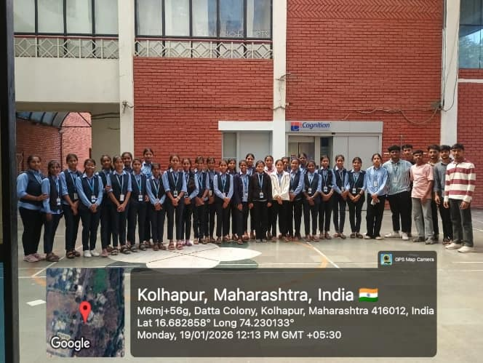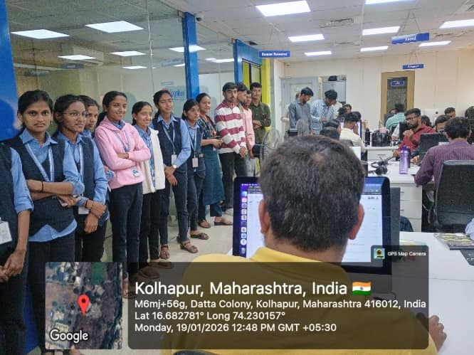
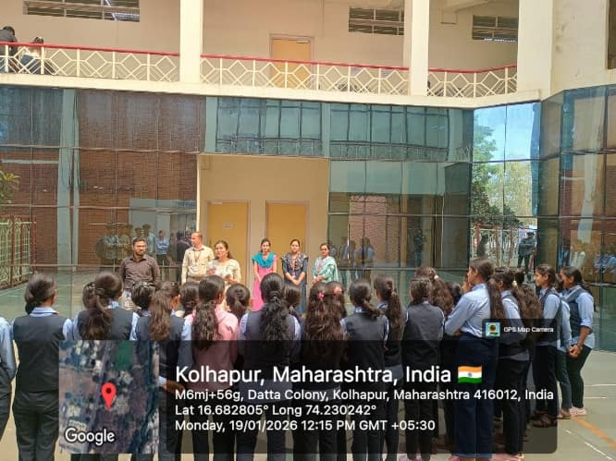

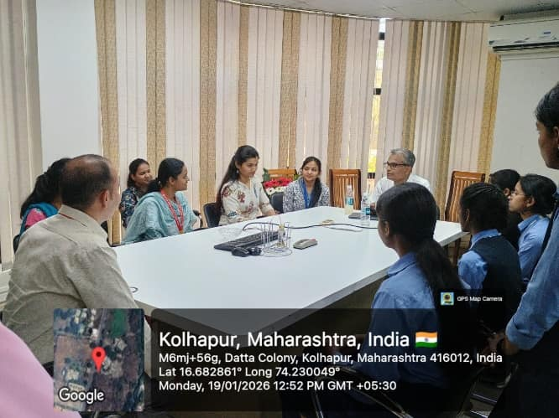
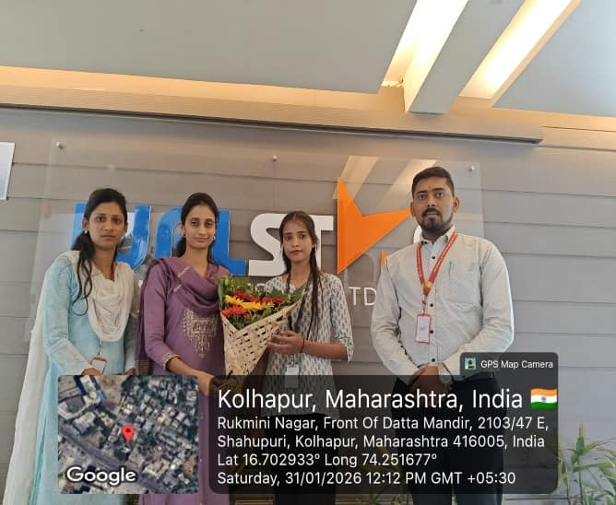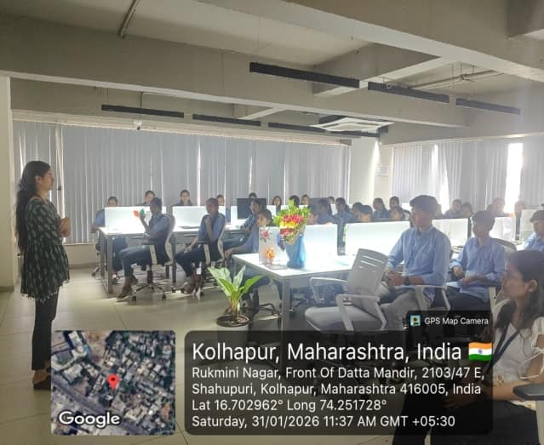

Guest Lecture:

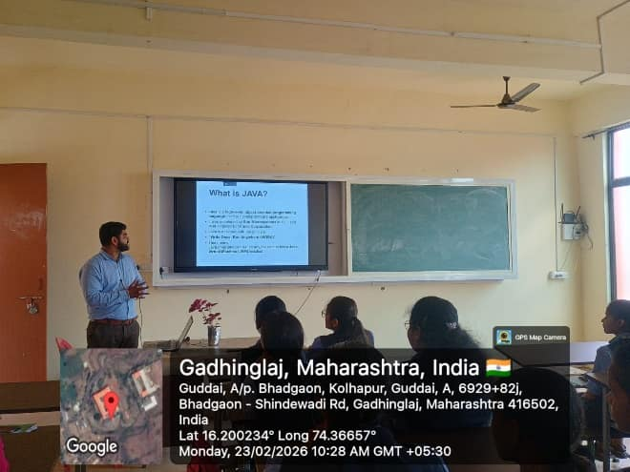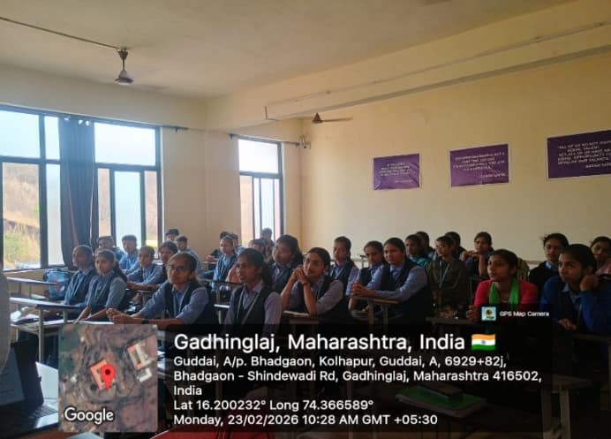

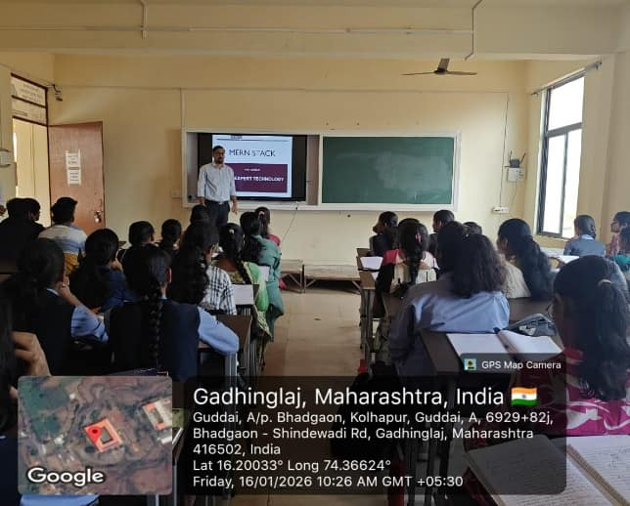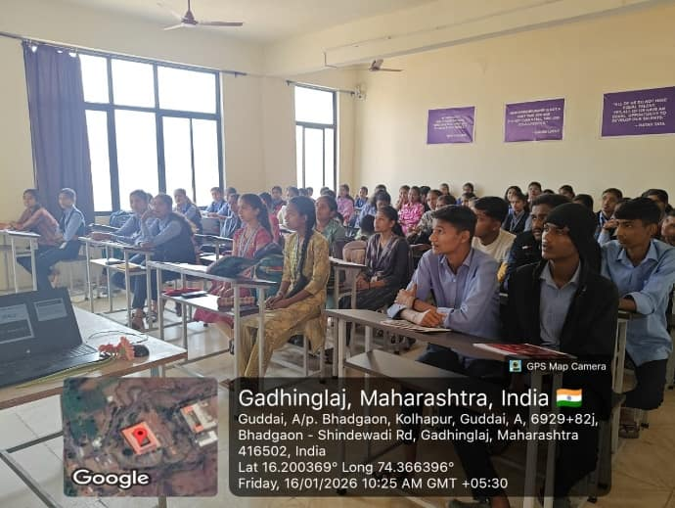

Pragyan 2K25:
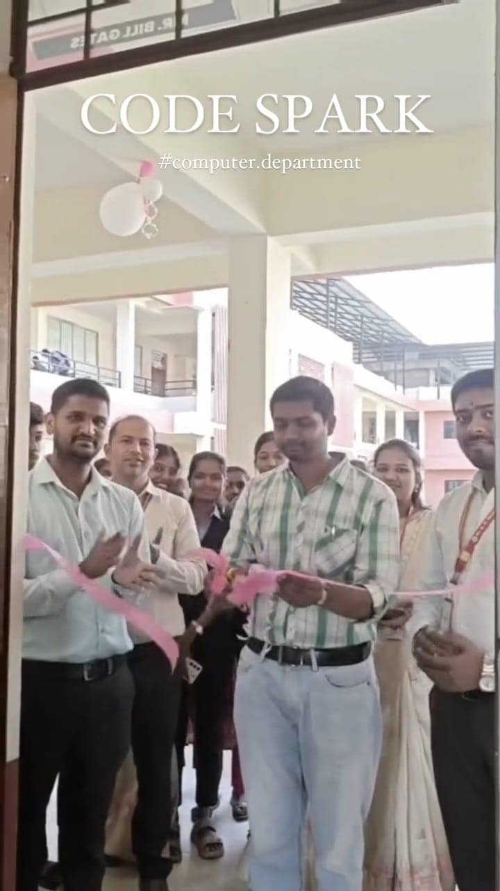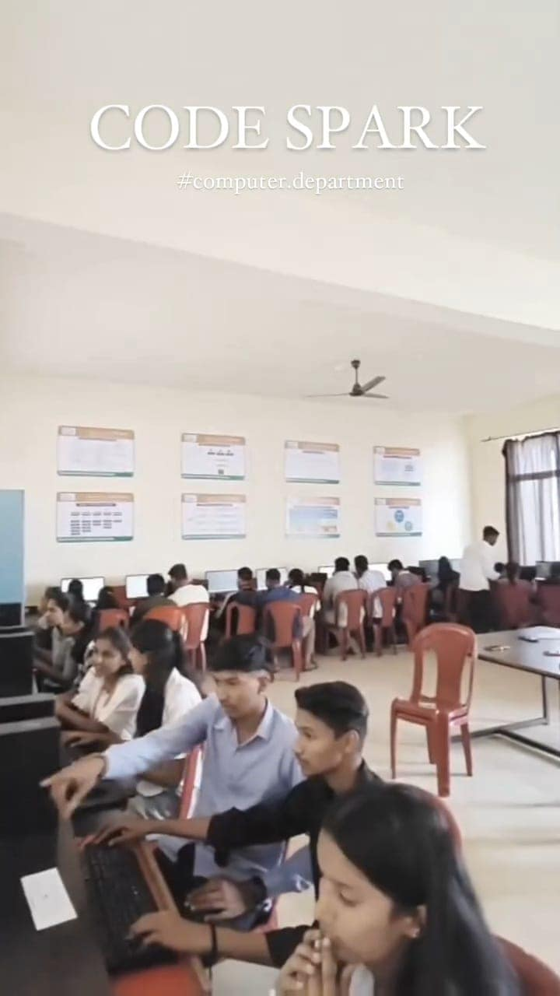

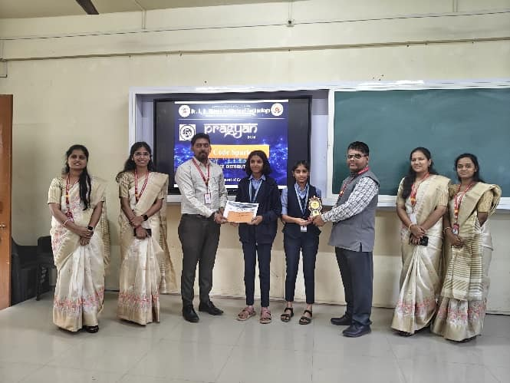

Rhythm 2K26:

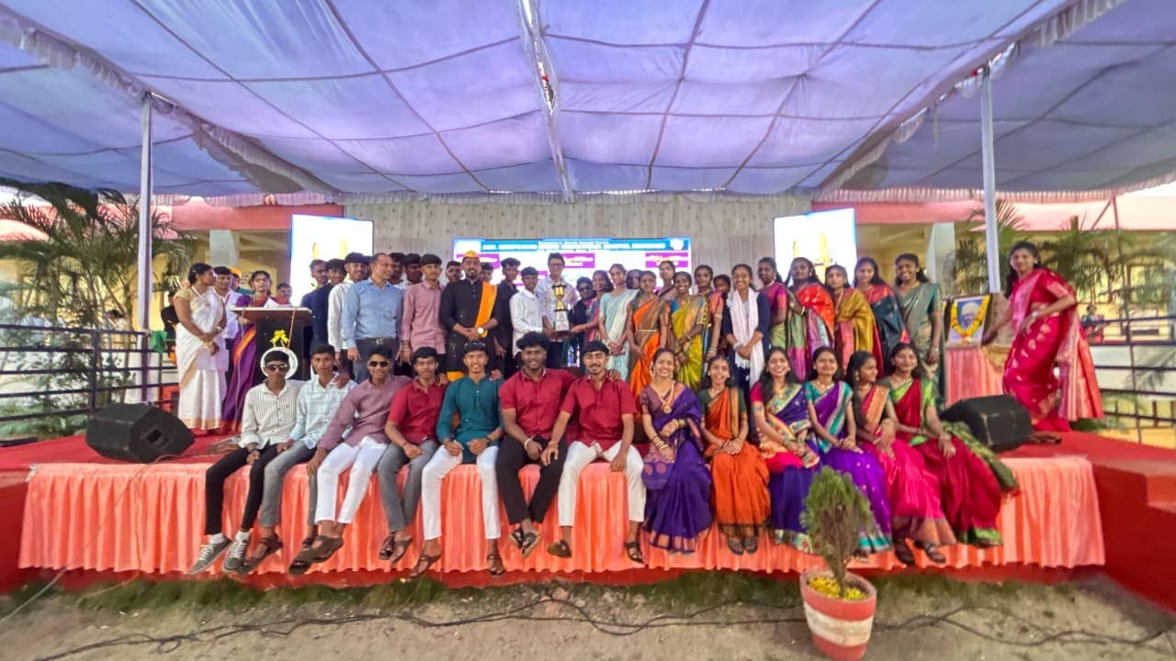

===========================================================================
DEPARTMENT OF COMPUTER ENGINEERING
DR. A. D. SHINDE INSTITUTE OF TECHNOLOGY
Guddai, Bhadgaon (Gadhinglaj), Dist- Kolhapur, 416502
www.adshindeiot.com

